Stat 135 Homework 4

1. Using the maximum likelihood estimator method, my calculated estimate for λ is 0.01283957 while my estimate for α is 1.026334. However, using the method of moments, my calculated estimate for λ is 0.0127 while my estimate for α is 1.0124. It is clear to see that the MLE estimates are slightly higher than the Method of Moment estimates. The fitted gamma distribution is graphed below (in blue) on top of the original histogram:

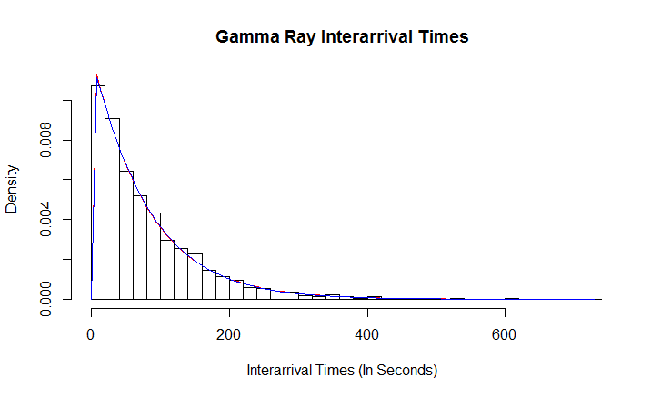

We can clearly see the gamma distribution with the estimated parameters is a good fit for this dataset. It peaks early, and declines as time increases in a similar fashion to the dataset. Moreover, it closely follows the dataset when it gets very thin towards the end.

Using the bootstrap method, 10,000 samples of size 3935 were created from the Method of Moments (MoM) and MLE parameters. Then, the MoM and MLE parameters of *each* sample were calculated, and the standard deviation of these 1000 parameters is the standard error of our original MoM or MLE estimate. After running the process, the standard error of MoM Alpha is 0.03171486, the SE of MoM Lambda is 0.0004469978, the SE of MLE Alpha is 0.0205274 and the SE of MLE Lambda is 0.000204556. It is evident that the SE’s of the MLE estimates are lower than the MoM estimates.